ADHD AND EXERCISE
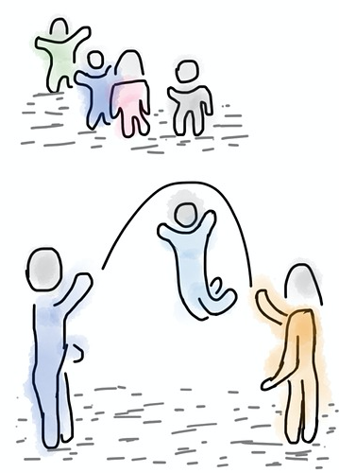When a child has attention deficit hyperactivity disorder, or ADHD, they have a mental disorder that may cause them to be hyperactive, have difficulty with impulse control, or struggle to pay attention. These symptoms may change or be different in adults with ADHD. Adults may have low self-esteem, be procrastinators, have mood swings, and deal with problems with relationships or at work, for example. It is typically diagnosed when a person is a child and affects boys more than girls. Statistically, between 5 and 11 percent of children between the ages of 4 and 17 have been diagnosed with ADHD, although some people are diagnosed at an older age. Medication and behavioral therapy are typically used in its treatment; however, studies have shown that exercise can also have a positive impact and may be as effective as medication.

EXERCISE AND THE BRAIN
Exercise can cause positive changes in both the brain and the body, according to research. It does this by causing new blood vessel adaptations and the growth of new nerve cells. In addition, when a person exercises or participates in physical activities, neurotransmitters such as norepinephrine and dopamine are released. These are important in terms of attention and focus. The growth of new nerve cells, which is known as neurogenesis, can improve cognition. Neurogenesis can take place in the hippocampus, which is the area where a large part of learning and memory take place. When exercise causes new blood vessels to form in the brain, it improves brain function and circulation. Exercise also has a positive impact on the prefrontal cortex, which plays a role in controlling working memory, and how it functions. Working memory temporarily stores memories and helps with learning and other cognitive tasks.

REASONS TO EXERCISE
There are many reasons for children and adults to exercise; the most common of these reasons is to lose weight or stay physically fit and healthy. It can help lessen the chances of developing heart problems, diabetes, and high blood pressure, and in those already diagnosed with these conditions, it may even help to control them. In people with ADHD, there is an additional reason why exercise is important. The increase in neurotransmitters such as dopamine may help with their performance in school or at work by allowing them to focus better, reduce fidgeting, and tune out distractions. In addition, exercise can also help improve confidence and raise one’s self-esteem. In adults, it can also reduce anxiety and compulsive behavior as well as improve their ability to remember details.

HOW OFTEN SHOULD YOU EXERCISE?
While any amount of exercise can help to some degree, it is important to do so regularly for the best results in terms of both ADHD and physical health. Kids should get out and exercise for a minimum of 60 minutes a day. This should be moderate to intense and may include activities such as playing group sports or riding a bike. Some studies, however, indicate that even a 20-minute walk outdoors can be beneficial and help a child with ADHD to relax. Adults should aim for at least 30 minutes of exercise a day, five days a week. Exercise for adults can include things like taking an aerobics class at the gym or jogging daily at a moderate to intense level.
- Adult ADHD and Exercise
- Exercise Is ADHD Medicine
- A Little Exercise May Help Kids With ADHD Focus
- New Study Suggests Exercise Can Help Kids With ADHD (video)
- Brain Games and Exercise: A Drug-Free Treatment for ADHD
- The Mental Health Benefits of Exercise
- Exercise Boosts School Performance for Kids With ADHD: Study
- ADHD Treatment Is Getting a Workout
- Dartmouth Researchers Are Learning How Exercise Affects the Brain
- Exercise and the Brain: It Will Make You Want to Work Out
- Can Physical Activity Help Children With ADHD?
- A Little Exercise May Help Kids With ADHD Focus
- Adult ADHD: Healthy Habits to Help You Focus
- Exercise and the Brain (video)
- How Exercise Beefs Up the Brain
- The Genius of Cardio
- Exercise for Your Brain
- The Brain Benefits First From Exercise
- Beginning in Infancy, Exercise Helps the Brain as Much as the Body
- American Psychological Association: The Exercise Effect
- Exercise Helps Mental Health
- How Much Should You Exercise?
- Exercise: An Alternative ADHD Treatment Without Side-Effects
- Great Activities for Kids With ADHD
- Exercise and ADHD
- The Exercise Prescription
- Exercise May Lead to Better School Performance for Kids With ADHD
- Measurement of the Effect of Physical Exercise on the Concentration of Individuals With ADHD

